***** CLASS SET *****

Life in Medieval Europe DBQ

Introduction: The Medieval Era, also known as the Middle Ages, in Europe was a period of time from approximately 500 AD to 1400 AD. It began with the destruction of the Roman Empire and the disorder that followed, which led to the rise of feudalism. During this period, also known as the Dark Ages, the Roman Catholic Church provided spiritual direction and also served many non-religious functions. Many literary, artistic, and architectural advances occurred.

Topic 1: Safety & Security
DOCUMENT A: Defend Your Religion
Source: Pope Urban’s Call to Fight
In 1095, Pope Urban II issued a call to European Christians for a holy crusade—a war to recapture the Holy Land.
…Your brethren [brothers] who live in the (Middle) East are in urgent need of your help…For, as most of you have heard, the Turks and the Arabs have attacked them and have conquered the territory of Romania (the Byzantine Empire)…They have occupied more and more of the lands of those Christians…They have killed and captured many, and have destroyed the churches and devastated the Empire…

DOCUMENT B: Social Hierarchy
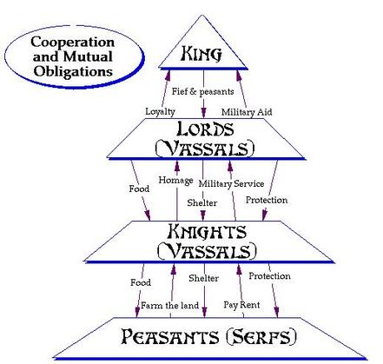

Source: World History Patterns of Interaction

DOCUMENT C: Invasion!
Source: The Anglo-Saxon Chronicle tells of invasions of England 842.
In this year there was a great slaughter in London and Quentavic and in Rochester 846. According to their custom the Northmen plundered… and burned the town of Dordrecht… the Northmen, with their boats filled with immense booty [treasure], including both men and goods, returned to their own country...

Topic 2: The Church
DOCUMENT D: Role of Roman Catholicism
Source: http://www.mnsu.edu/emuseum/history/middleages/church.html

The role of the Church was of extreme importance in Medieval Europe. More than any other institution, it unified Europeans and gave every person a sense of how the world worked. Since political leaders only had local power, the Church was the most powerful institution. This secondary source describes the multiple roles the Church played in the Middle Ages.
In a time of great political chaos, the Roman Catholic Church was the single, largest unifying structure in medieval Europe. It touched everyone's life, no matter what their rank or class or where they lived. With the exception of a small number of Jews, everyone in Europe was a Christian during the Middle Ages from the richest king down to the lowest serf.

From the moment of its baptism a few days after birth, a child entered into a life of service to God and God's Church. As a child grew, it would be taught basic prayers, would go to church every week barring illness, and would learn of its responsibilities to the Church. Every person was required to live by the Church's laws and to pay heavy taxes to support the Church. In return for this, they were shown the way to everlasting life and happiness after lives that were often short and hard.

In addition to collecting taxes, the Church also accepted gifts of all kinds from individuals who wanted special favors or wanted to be certain of a place in heaven. These gifts included land, flocks, crops, and even serfs. This allowed the Church to become very powerful, and it often used this power to influence kings to do as it wanted.

Topic 3: Daily Life
DOCUMENT E: Peasant Living

Source: http://www.historylearningsite.co.uk/medieval-england/the-lifestyle-of-medieval-peasants/
The houses would have had none of the things we accept as normal today – no running water, no toilets, no baths and washing basins. Soap was unheard of and as was shampoo. People would have been covered with dirt, fleas and lice. Beds were simply straw stuffed mattresses and these would have attracted lice, fleas and all types of bugs. Your toilet would have been a bucket which would have been emptied into the nearest river at the start of the day.
Families would have cooked and slept in the same room. Children would have slept in a loft if the cruck house was big enough.

The lives of peasant children would have been very different to today. They would not have attended school for a start. Very many would have died before they were six months old as disease would have been very common. As soon as was possible, children joined their parents working on the land. They could not do any major physical work but they could clear stones off the land – which might damage farming tools – and they could be used to chase birds away during the time when seeds were sown. Peasant children could only look forward to a life of great hardship.

DOCUMENT F: Piers Plowman Poem
The Peasant’s Cares
The most needy are our neighbors, if we notice right well,
As prisoners in pits and poor folk in cottages,
Charged with their children, and chief lord’s rent,
What by spinning they save, they spend it in house-hire,
Both in milk and in meal to make a mess of porridge.
To cheer up their children who chafe for their food,
And they themselves suffer surely much hunger
And woe in the winter, with waking at nights
And rising to rock an oft restless cradle,
Both to card and to comb, to clout and to wash,
To rub and to reel yarn, rushes to peel,
So ‘tis pity to proclaim or in poetry to show
The woe of these women who would in such cottages;
And of many other men who much woe suffer
Crippled with hunger and with thirst, they keep up appearances
And are abashed for to beg, and will not be blazoned
What they need from their neighbours, at noon at and at evensong
This I know full well, for the world has taught me
How churls are afflicted who have many children,
And have no coin but their craft to clothe and to keep them.

Source: Piers Plowman, in World History Patterns of Interaction Literature Section.
For the majority of Europeans, life was hard. Serfs, or peasants obligated to work the lord’s land, had no freedoms. Serfs worked for six days of the week and received one day to farm and collect food for their own families, and were also expected to pay rent to their lords to use their land. In return for their labor, the serfs could depend on their lord for housing, food, and protection from raiding invaders.
Piers Plowman is an English poem written by a London priest, William Langland, in 1362. He spent many years working in rural areas and learned firsthand about peasant life.

Topic 4: Health
DOCUMENT G: Managing the Plague
Source: Medieval Plague Doctor, Doktor Schnabel von Rom ("Doctor Beak of Rome" in German), Engraving by Paul Fürst, 1656
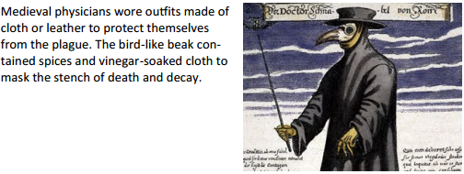

DOCUMENT H: The Practice of Medicine
The practice of medicine in the Middle Ages was rooted in the Greek tradition. Hippocrates, considered the “father of Medicine,” described the body as made up of four humors—yellow bile, phlegm, black bile, and blood—and controlled by the four elements—fire, water, earth, and air. The body could be purged of excess by bleeding, cupping, and leeching—medical practices that continued throughout the Middle Ages.
Surgery such as amputations, cauterization, removal of cataracts, dental extractions, and even trepanning (perforating the skull to relieve pressure on the brain) were practiced. Surgeons would have relied on opiates for anesthesia and doused wounds with wine as a form of antiseptic.

