The Renaissance: Causes, Effects, and Art

Renaissance means _________________
How did the Renaissance start?
What caused the Renaissance?

Renaissance effects from the song
What was the philosophy of humanism?
What was the Renaissance?
What effects did the Renaissance have?

Art
 | What details do you see? | Who do you think he was?
 | What is the man doing? | Why would Myron have created this piece?
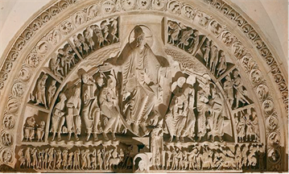 | What details do you see? | How is he different from the others?
 | Who is depicted in the center? | Why would this have been created?
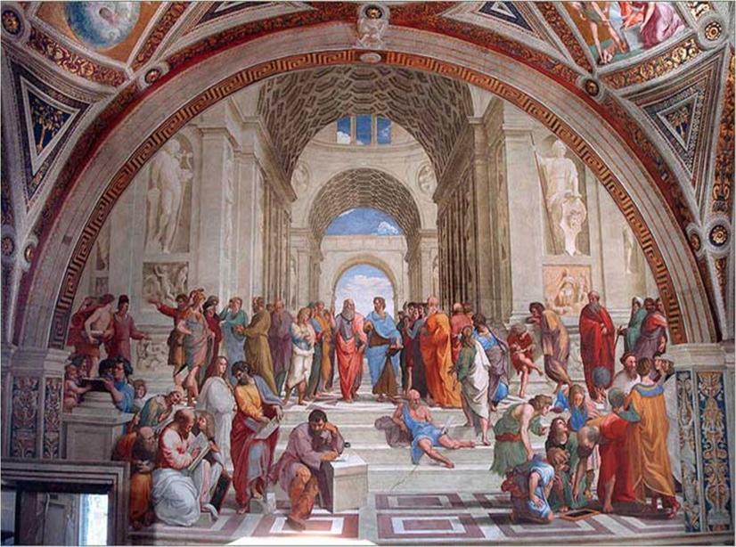 | What details do you see? | How is this piece of art different from the others?
 | Who is depicted in the center? | Why would this have been created?

Comparison of Artistic Styles: Classical Era, Medieval Era, and Renaissance Era
 | Classical | Medieval | Renaissance
Purpose of the Art
Characteristics of the Art
Architecture

Literature

