Classical Era Review KEY 2018-2019

**Characteristics of Empires & Persian Empire**

1. List the seven main characteristics of an empire.

* Strong Central Administration (bureaucracy) –collect taxes & tribute, enforce laws
* Common Language- necessary for govt. officials to talk to each other, efficient communication
* Economic Growth –
* Imperial Cities
* Monumental Structures – inspired citizens, intimidated visitors with the ruler’s power
* Ideology- system of beliefs that allowed the people to connect with the emperor, legitimizes rule. China – Mandate of Heaven; India – caste system
* Strong Military Power – Protect borders of empire, prevent rebellion of conquered people, conquer more territory. Expensive to train & maintain, and needed roads to be effective.

1. Explain how empires successfully had strong economic growth.

Charged citizens taxes and required tributes

1. How did the Persians build and maintain their large empire?

Built the Royal Road, religious tolerance, system of satraps for organization

1. What was the purpose of the Royal Road?

Travel, communication, mail

**Ancient Greece**

1. What new type of government did Athens create?

Democracy

1. Define democracy and oligarchy.

* Democracy – “rule of the many”; govt. controlled by the people through elections and voting. Can be direct (everyone votes on issues) or indirect (representatives)
* Oligarchy – “rule of the few”; govt. controlled by a few wealthy individuals

1. What caused the city-states of Greece develop separate governments and differing cultural characteristics?

Greek geography (mountains, coasts) kept city-states isolated

1. How did Athens and Sparta differ politically and culturally?

* Athens – direct democracy. Citizens voted to make laws and control city. Had access to ocean – increased exposure to other cultures caused development of art, science, math and philosophy
* Sparta – oligarchy. Ruled by military leaders, mandatory service in the military for males.

1. What are the major mathematical, scientific, and technological advancements made in Greece during the Classical Era?

* 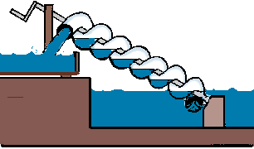value of *pi* (3.14)- Archimedes, geometry (Euclid), Pythagorean theorem A2 + B2 = C2
* architecture, philosophy, Archimedes Screw
* star charts and leap year calendar, circumference of the earth

**Ashoka Unifies India**

1. What was the caste system?

Rigid social class structure. Indians were born into a caste and stayed in it for life.

1. How did Ashoka improve his society in Classical India?

Roads to improve trade & communication, spread Buddhism

1. What are the major advancements made in India during the Classical Era?

Concept of zero, decimal system, number system used today, basic geometry, circumference of the earth

1. Explain the central ideas of Hinduism, including reincarnation, karma, dharma, and moksha.

Reincarnation – cycle of rebirth (karma, dharma & moksha)

Karma – idea that your good & bad deeds influence your next life

Dharma – idea that it is better to fulfill your own destiny than try to be something you’re not (better to be a bad warrior if that’s your caste than the best baker)

Moksha – Freedom from the cycle of rebirth by achieving enlightenment (to become one with the Brahman, the great world soul.)

1. Who was the founder of Buddhism?

* Siddhartha Gautama - Hindu prince who became aware of the suffering in the world, abandoned his life of luxury to reform Hinduism in order to solve the problem of suffering, and became enlightened through meditation and was renamed the Buddha

1. Explain the central ideas of Buddhism..

* Caste system creates suffering.
* 4 Noble truths
  1. 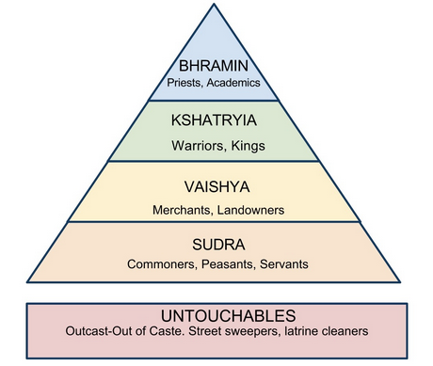All life is suffering.
  2. Suffering is caused by desire.
  3. To end suffering, end desire.
  4. To end desire, follow the Eightfold Path.
* By following the Eightfold path, people could free themselves from the cycle of reincarnation and achieve nirvana in this life, even if they were a low caste.

-Appealed to the untouchables

* Spreads to East Asia through travel, trade, & missionaries

1. Which Indian religion used the caste system?

* Hinduism – Buddhism disagreed with it

**China Builds a Bureaucracy**

1. ****Explain the basic characteristics of Legalism.

* Qin dynasty belief that people are naturally wicked/evil & required harsh laws to force them to behave morally

1. Explain the basic characteristics of Daoism.

believes humans can achieve peace & happiness by living simply, in harmony with nature

1. Explain the philosophy of Confucianism.

humans are basically good, and can achieve a peaceful society by being obedient to those in authority & focusing on the 5 important relationships & filial piety.

1. What is filial piety?

Respecting one’s elders, especially parents, grandparents, ancestors.

1. Explain the ideology of the Mandate of Heaven.

The idea that a family had the right to rule from god. When thigns began to go badly, it indicated that dynasty had lost the Mandate of Heaven & then a new strong family would emerge from the chaos- gaining the Mandate of Heaven.

1. What contributions did the Zhou Dynasty add to Chinese history?

* Belief in the dynastic cycle and the mandate of heaven

1. How did the ruler of the Qin Dynasty implement Legalism in China?

Passed harsh laws, punished/killed anyone who disagreed with them

1. How did various regions of China become more united in the Classical Era?

Created one money system, built roads, started Great Wall of China, strong central administration

1. How did the Han Dynasty develop a strong centralized bureaucracy?

Created civil service exams – tests to see if a person was qualified to work in the government

* + Allowed lower class people to improve their lives through hard work and study
  + Guaranteed to have educated people in govt.

1. Identify major technological advances made in China during the classical period.

Paper (Han), Great Wall (Qin), Grand Canal

**Roman Republic**

1. How was the Roman republic structured?

Separate branches of government, like the US now Senate – had the most power

1. What were the Twelve Tables?

Roman code of law

1. How did the Twelve Tables impact western civilizations?

Many western (European/North American) nations use the principles from the Twelve Tables today

1. What are three major legal concepts from Rome that are used today in the United States?
   * Rule of law – all citizens are equal under the law
   * Innocent until proven guilty
   * right to face your accuser
2. What are the origins of Christianity?

* Jesus of Nazareth – born Jewish in Israel. Believed to be the “Son of God”, and to have died on the cross to redeem mankind’s sins. His apostles spread his teachings after his death.

1. What factors allowed Christianity to spread throughout the Roman Empire?

* good roads, a common language during *Pax Romana* that allowed it to spread
* Message of equality = important to common people/slaves within the Roman Empire.

1. How did Roman policy toward Christians change during the Roman Empire?

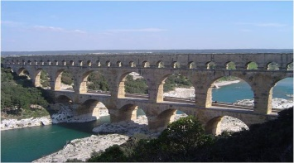Emperor Constantine legalized Christianity

1. What the major technological advances made in Rome during the classical period?

Aqueducts, roads

**Collapse of Rome & Han China**

1. What caused the collapse of both the Roman Empire and Han Dynasty fall?

Barbarian invasions, grew too large, plagues spread & caused many deaths, corruption

1. How did plagues cause financial problems for the Roman and Han government?

Fewer citizens = less tax & tribute income

1. Explain the differences between the collapse of the Roman Empire and the Han Dynasty.

* China’s Han dynasty eventually regained power (Dynastic Cycle)
* Roman Empire divided- Byzantine Empire (east) and Western Europe